1.(a) what is the benefit of binary search over linear search?
A linear search, sometimes referred to as a sequential search, simply scans each element one at a time. In this search, an array is sequentially traversed from the first element until the element is found or the end of the array is reached. This method can only be suitable for searching over a small array or an unsorted array.
Binary search: The Binary search method is only suitable for searching in a sorted array. In this method, the element that has to be searched is compared to the array's middle element. Search is considered successful only if it matches the target.
The binary search algorithm uses the divide-and-conquer approach, it does not scan every element in the list, it only searches half of the list instead of going through each element, Hence said to be the best searching algorithm because it is faster to execute as compared to Linear search.
1.(b) maze (1:6,-4:1,5:10) is a 3D array with base=100,w=4,calculate maze[3,-2,8]address in a row major order and column major order.
https://shorturl.at/hSUV2
1.(c) we often store sparse matrix in a 1D array to save spaces. what is the memory saving if we store a sparse matrix in a 1D array rater than a 2D array?
Ans: Storing a sparse matrix in a 1D array, rather than a 2D array, conserves memory by eliminating the need to store numerous zero elements. In a 2D array, each cell occupies memory regardless of content, while a 1D array stores only the non-zero elements and their corresponding indices. This reduction in memory usage can be substantial, especially for matrices with a low density of non-zero values. The saved memory is proportional to the number of zero elements avoided, resulting in significant space efficiency for sparse matrices stored in a 1D array.
2.(a) what is a linked list? What is the main differences between the linked list and linear array?
A linked list is a linear data structure, in which the elements are not stored at contiguous memory locations. The elements in a linked list are linked using pointers as shown in the below image:
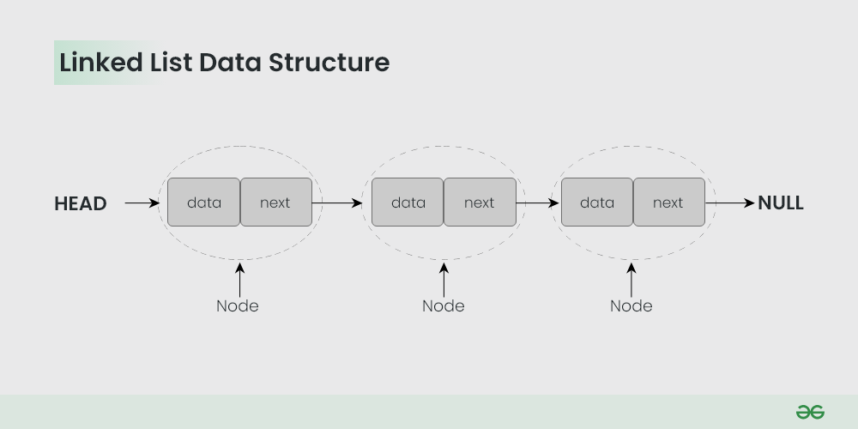

Major differences between array and linked-list are listed below:
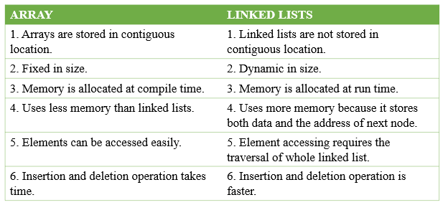
Please write comments if you find anything incorrect, or if you want to share more information about the topic discussed above.

2.(b) briefly discuss the terms garbage collection ,overflow and underflow.
The garbage collection may occur when small amount of free space is left in the system or no free space is left in the system or when CPU is idle and has time to do the garbage collection.
Overflow happens at the time of insertion. If we have to insert new space into the data structure, but there is no free space i.e. availability list is empty, then this situation is called ‘Overflow’. The programmer can handle this situation by printing the message of OVERFLOW.
Underflow happens at the time of deletion. If we have to delete data from the data structure, but there is no data in the data structure i.e. data structure is empty, then this situation is called ‘Underflow’. The programmer can handle this situation by printing the message of UNDERFLOW.
2.(c) one of the advantages of linked list is the ability the insert data into the list easily . Explain with your own words and figures how to insert data at the beginning, after a given node, at the end and to a sorted list.
Given a Linked List, the task is to insert a new node in this given Linked List at the following positions:
- At the front of the linked list
- After a given node.
- At the end of the linked list.
Beginning of Linked List:
To insert a node at the start/beginning/front of a Linked List, we need to:
- Make the first node of Linked List linked to the new node
- Remove the head from the original first node of Linked List
- Make the new node as the Head of the Linked List.
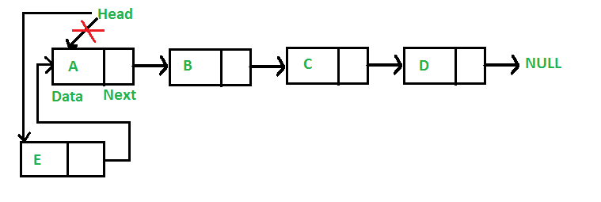
Insert a Node after a Given Node in Linked List
To insert a node after a given node in a Linked List, we need to:
- Check if the given node exists or not.
  - If it do not exists,
    - terminate the process.
  - If the given node exists,
    - Make the element to be inserted as a new node
    - Change the next pointer of given node to the new node
    - Now shift the original next pointer of given node to the next pointer of new node
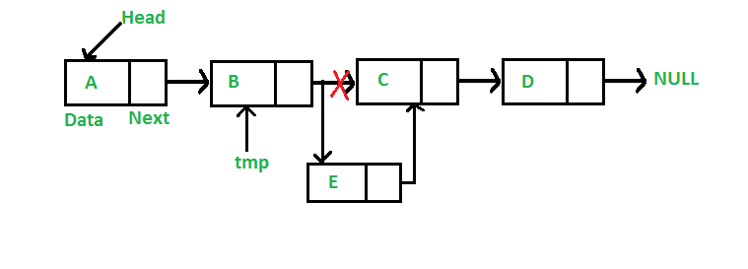
Insert a Node at the End of Linked List
To insert a node at the end of a Linked List, we need to:
- Go to the last node of the Linked List
- Change the next pointer of last node from NULL to the new node
- Make the next pointer of new node as NULL to show the end of Linked List
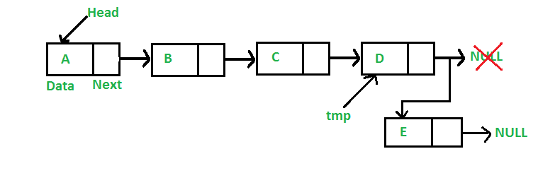

Inserting data into a sorted linked list involves finding the appropriate position based on the data's value and then creating a new node to hold the data. This new node is linked into the list by adjusting pointers of adjacent nodes. This maintains the list's sorted order while accommodating the new data efficiently.
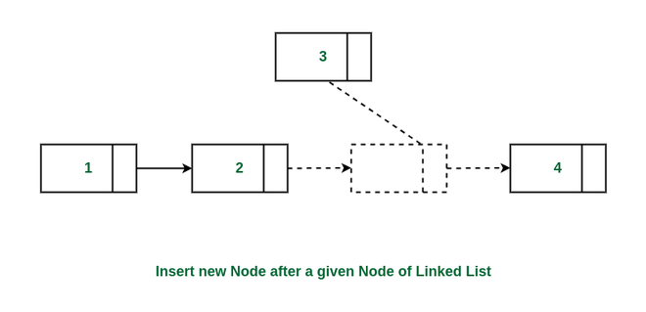

3 (a). Define stack. Explain the usage of stack in recursive algorithm implementation.
Stack is a linear data structure that follows a particular order in which the operations are performed. The order may be LIFO(Last In First Out) or FILO(First In Last Out). LIFO implies that the element that is inserted last, comes out first and FILO implies that the element that is inserted first, comes out last.
Recursion is an amazing technique with the help of which we can reduce the length of our code and make it easier to read and write. It has certain advantages over the iteration technique which will be discussed later. A task that can be defined with its similar subtask, recursion is one of the best solutions for it. For example; The Factorial of a number.
- Recursion technique is relatively more efficient than iterative technique in terms of time complexity according to modern CPU systems.
- Space complexity of recursive code is higher because of the consumption of call stack.
3 (b). Simulate the infix to postfix transformation algorithm for
Q:A+(B*C-(D/E↑F)*G)*H
By showing the stack’s contents as each element is scanned.
3 (c). write down a routine to insert an element onto queue.
insert an element onto a queue, you can follow these steps:
- Check if the Queue is Full (if applicable): If your queue has a maximum capacity, you need to check if the queue is already full before inserting a new element. If it's full, you may need to handle overflow conditions.
- Insert the Element: To insert an element onto the queue, you typically perform the following steps:
- Add the new element to the end of the queue data structure.
- Update any pointers or variables that track the front and rear of the queue.
- Update Rear Pointer: After inserting the element, update the rear (tail) pointer of the queue to point to the newly inserted element.
4 (a) what is hash function?
A Hash Function is a function that converts a given numeric or alphanumeric key to a small practical integer value. The mapped integer value is used as an index in the hash table. In simple terms, a hash function maps a significant number or string to a small integer that can be used as the index in the hash table.
The pair is of the form (key, value), where for a given key, one can find a value using some kind of a “function” that maps keys to values. The key for a given object can be calculated using a function called a hash function. For example, given an array A, if i is the key, then we can find the value by simply looking up A[i].
4 (b) the keys 14,12,18,13,2,3,23,5 and 15 are inserted into an initially empty hash table of length 10 using open addressing with hash function h(k)=k mod 10 and plus 3 probing. What is the resultant hash table?

https://byjus.com/question-answer/n-4248/

4 (c) A hash table of length 10 uses open addressing with hash function h(k) =k mod 10, and linear probing. After inserting 6 values into an empty hash table ,the table is as shown below
 |  | 42 | 23 | 34 | 52 | 46 | 33
0 | 1 | 2 | 3 | 4 | 5 | 6 | 7 | 8 | 9
Which one of the following choices gives a possible order in which the key values could have been inserted in the table?
- 46,42,34,52,23,33,
- 34,42,23,52,33,46
- 46,34,42,23,52,33
- 42,46,33,23,34,52
We will check whether sequence given in option A can lead to hash table given in question. Option A inserts 46, 42, 34, 52, 23, 33 as:
For key 46, h(46) is 46%10 = 6. Therefore, 46 is placed at 6th index in the hash table.
For key 42, h(42) is 42%10 = 2. Therefore, 42 is placed at 2nd index in the hash table.
For key 34, h(34) is 34%10 = 4. Therefore, 34 is placed at 4th index in the hash table.
For key 52, h(52) is 52%10 = 2. However, index 2 is occupied with 42. Therefore, 52 is placed at 3rd index in the hash table. But in given hash table, 52 is placed at 5th index. Therefore, sequence in option A can’t generate hash table given in question.
In the similar way, we can check for other options as well which leads to answer as (C).

5 (a) Define the terms (i) siblings, (ii) ancestor, and (iii) depth of a binary tree.
In a tree data structure, nodes which belong to same Parent are called as SIBLINGS. In simple words, the nodes with the same parent are called Sibling nodes.
ancestor :A parent of a node in a tree, the parent of the parent, etc.
The depth of a node is the number of edges present in path from the root node of a tree to that node.

5 (b) Tree traversal (also known as walking the tree) refers to the process of visiting each node
exactly once. Simulate the preorder traversal algorithm for the following tree.
A
H
B
I
C
G

E
D
F

6.(a) What is adjacency matrix? How is it formed?
An adjacency matrix is a way of representing a graph as a matrix of boolean (0’s and 1’s).
Let’s assume there are n vertices in the graph So, create a 2D matrix adjMat[n][n] having dimension n x n.
- If there is an edge from vertex i to j, mark adjMat[i][j] as 1.
- If there is no edge from vertex i to j, mark adjMat[i][j] as 0.
Representation of Undirected Graph to Adjacency Matrix:
The below figure shows an undirected graph. Initially, the entire Matrix is ​​initialized to 0. If there is an edge from source to destination, we insert 1 to both cases (adjMat[destination] and adjMat[destination]) because we can go either way.
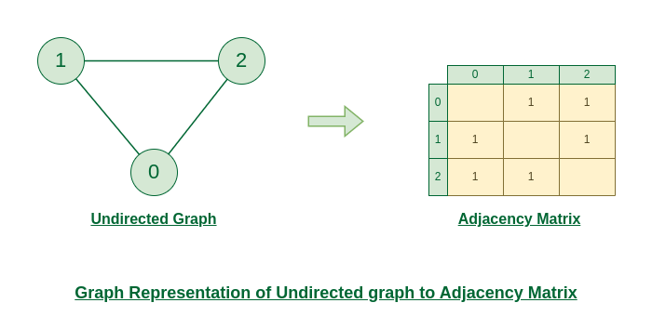

Representation of Directed Graph to Adjacency Matrix:
The below figure shows a directed graph. Initially, the entire Matrix is ​​initialized to 0. If there is an edge from source to destination, we insert 1 for that particular adjMat[destination].
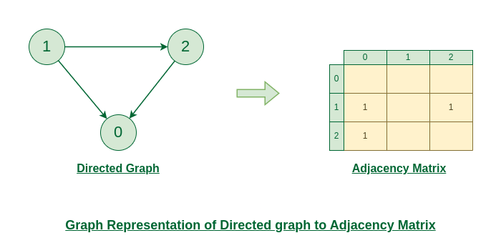

6.(b) Define the terms (i) Isolated node, (ii) Simple Path and (iii) Weighted Graph.

https://techvidvan.com/tutorials/graph-in-data-structure/
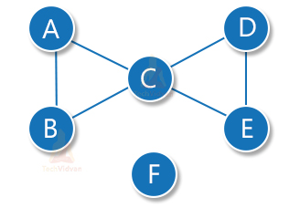
Isolated node: A node having degree = 0. Thus, an isolated node is not connected to any other node. Here, node F is the isolated node.
Simple path: A simple path is a path in which all the nodes are distinct.
Path without repetition of edges is called simple path.
Example: a,b,c,d,e
Weighted Graph
- A graph in which the edges are already specified with suitable weight is known as a weighted graph.
- Weighted graphs can be further classified as directed weighted graphs and undirected weighted graphs.
6.(c) How can you search '5' in the following binary search tree? However if '5' is not in the tree just insert to its appropriate place and show the resultant tree.
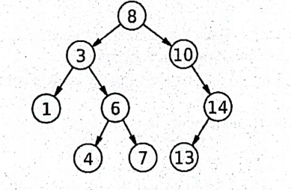
Let’s say we want to search for the number ‘5’, We start at the root. Then:
- We compare ‘5’ to be searched with the value of the root.
- If it’s equal we are done with the search if it’s smaller we know that we need to go to the left subtree because in a binary search tree all the elements in the left subtree are smaller and all the elements in the right subtree are larger.
- Repeat the above step till no more traversal is possible
- If at any iteration, key is found, return True. Else False.

How to Insert a value in a Binary Search Tree:
- Check the value to be inserted ‘5’ with the value of the current node ‘8’.
- When ,5 is less then 8 .so that move to left subtree.
- Here, the left sub-tree’s parent node is 3.
- When, 5 is bigger then 3. So that move to right child.
- When ,5 is less then 6 .so, that move to left.
- When, 5 is bigger then 4. so that move to right leaf node.
- This is the perfect position for the number of ‘5’.

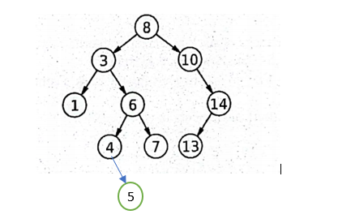

7(a) What is meant strongly and weakly connected in a graph?
- Strongly Connected: A graph is said to be strongly connected if every pair of vertices(u, v) in the graph contains a path between each other. In an unweighted directed graph G, every pair of vertices u and v should have a path in each direction between them i.e., bidirectional path. The elements of the path matrix of such a graph will contain all 1’s.
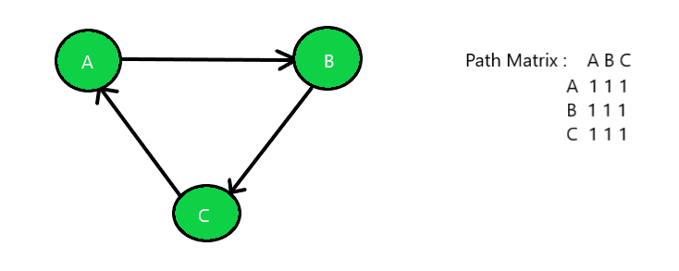
- Weakly Connected: A directed graph is weakly connected if there is a path between every two vertices in the underlying undirected graph (i.e, the graph formed when the direction of the edges are removed).
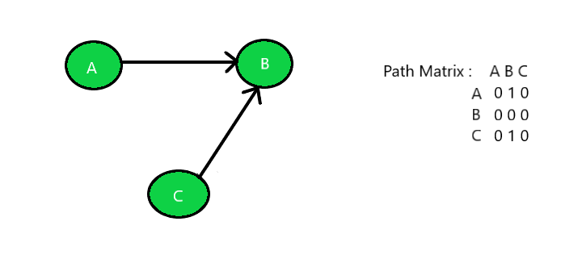

7(b) Prove that the maximum number of edges that a graph with n vertices is n* (n-1)/2.
We have that is a simple graph, no parallel or loop exist. Therefore the degree of each vertex will be one less than the total number of vertices (at most). ie, degree=n-1
eg. we have a graph with two vertices (so one edge) degree=(n-1).
(n-1)=(2-1)=1
We know that the sum of the degree in a simple graph always even ie, ∑d(v)=2E
here d(v)=n-1 : we have n vertices the total degree is n(n-1)
n*(n-1)=2E
E=n*(n−1)/2
7(c) Explain Breadth First search algorithm with example.
Let's see how the Breadth First Search algorithm works with an example. We use an undirected graph with 5 vertices.
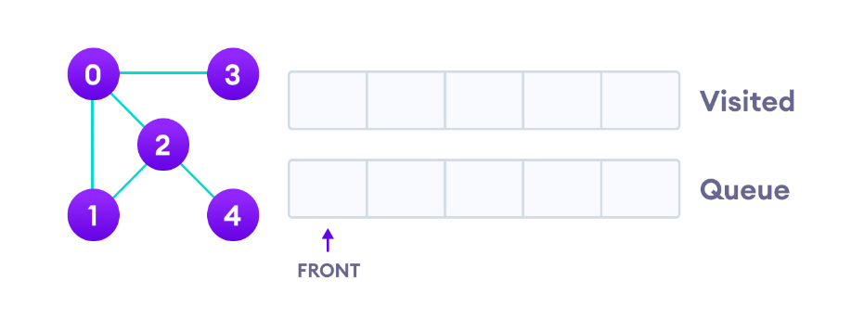
we start from vertex 0, the BFS algorithm starts by putting it in the Visited list and putting all its adjacent vertices in the stack.

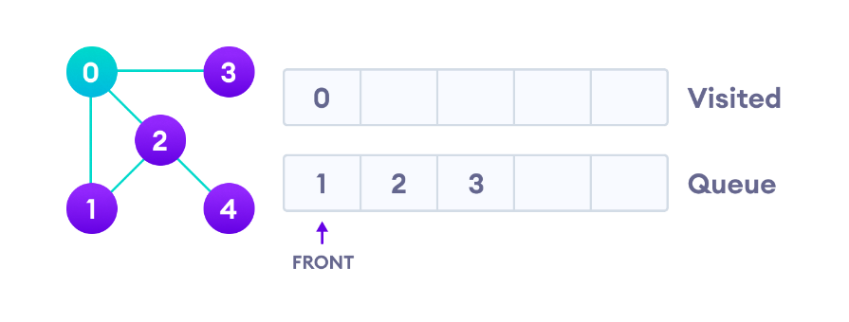
Next, we visit the element at the front of queue i.e. 1 and go to its adjacent nodes. Since 0 has already been visited, we visit 2 instead.
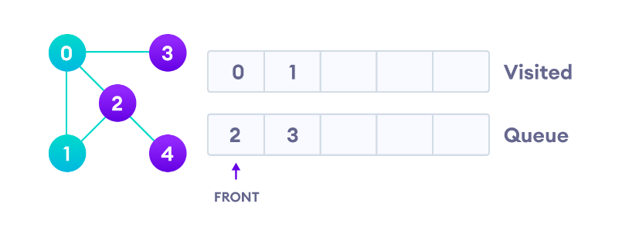
Vertex 2 has an unvisited adjacent vertex in 4, so we add that to the back of the queue and visit 3, which is at the front of the queue.

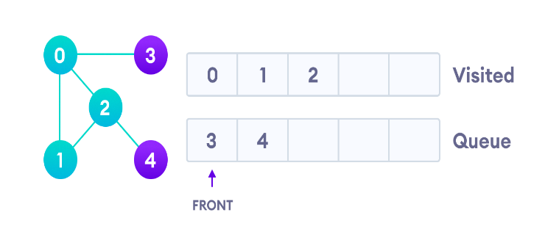
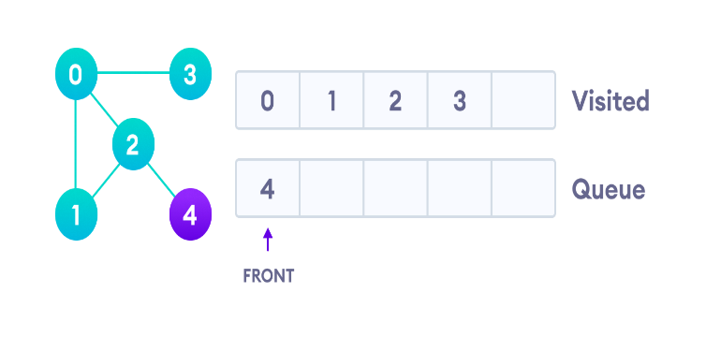

Only 4 remains in the queue since the only adjacent node of 3 i.e. 0 is already visited. We visit it.
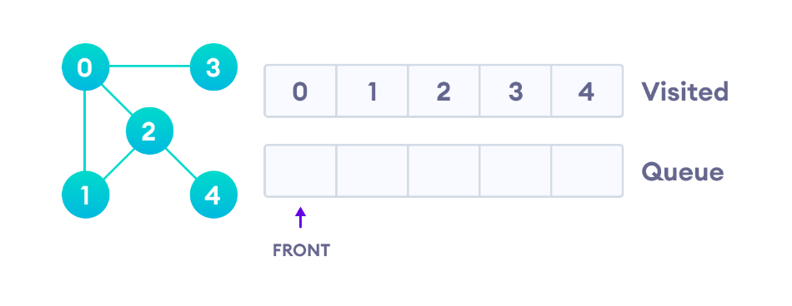
Since the queue is empty, we have completed the Breadth First Traversal of the graph.

8(a) Suppose we want to encode a message constructed from the symbols A, B, C, D, E, F and G using a fixed-length code. How many bits are required to encode the message FDEGAACAAGAAFABA?
To calculate the number of bits required to encode a message using a fixed-length code, you need to determine the number of symbols in your alphabet and then find the minimum number of bits needed to represent each symbol.
In your case, the alphabet consists of 7 symbols: A, B, C, D, E, F, and G.
To determine the minimum number of bits required to represent 7 symbols, you need to find the smallest power of 2 that is greater than or equal to 7. In this case, the smallest power of 2 greater than 7 is 2^3 = 8.
This means that you would need 3 bits to uniquely represent each symbol. Now you can calculate the number of bits required to encode the given message "FDEGAACAAGAAFABA," which has a length of 17 symbols:
Number of bits required = Number of symbols × Number of bits per symbol
Number of bits required = 17 symbols × 3 bits per symbol
Number of bits required = 51 bits .
So, you would need 51 bits to encode the message "FDEGAACAAGAAFABA" using a fixed-length code with the given alphabet.
(b) Build the Huffman coding tree for the message 'science engineering'.
Done.
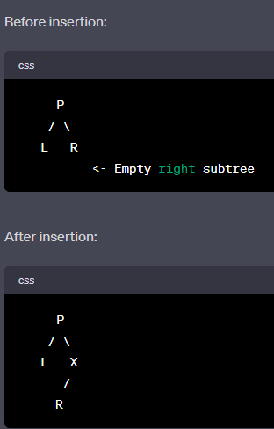
(c) Suppose you are to insert a node 'X' as the right child of node 'P'. Discuss the inserting mechanisms with figures.
i. When the right subtree of 'P' is empty.
Scenario i: When the right subtree of 'P' is empty
In this scenario, you simply need to create a new node 'X' and make it the right child of node 'P'.

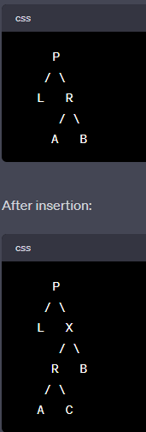
ii. When the right subtree of 'P' is not empty.
Scenario ii: When the right subtree of 'P' is not empty
In this scenario, you need to insert the new node 'X' into the existing right subtree of 'P'. This involves shifting the current right subtree down to become the right subtree of 'X'.

Explanation:
- Create a new node 'X'.
- Make the right child of 'P' as the left child of 'X'.
- Make 'X' the right child of 'P'.
In this way, you've inserted 'X' as the right child of 'P' while preserving the original right subtree of 'P'.
Remember, these explanations assume you are working with a binary tree data structure where each node can have at most two children (left and right). The mechanisms might vary if you're dealing with more complex tree structures.

